RBE 500

Homework 5b Solution

Problem 1

1. Assuming the measured values are in cm, we can see that there are 36 measurements above the maximum range of 40m. There are 1699 total measurements. The probability of an out of range measurement is 36/1699 = 0.021
2. 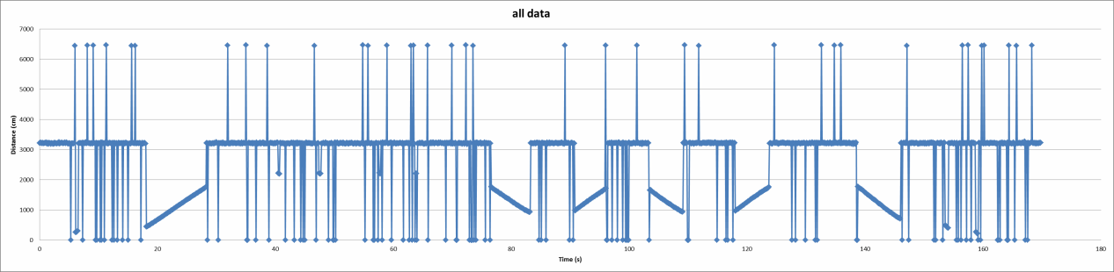

Because the minimum range is 5cm and everything we are measuring seems to be much farther than that I considered all data at 5cm and below as suspiciously minimum. This means that there are 101 measurements below my threshold. 101/1699 = 0.059

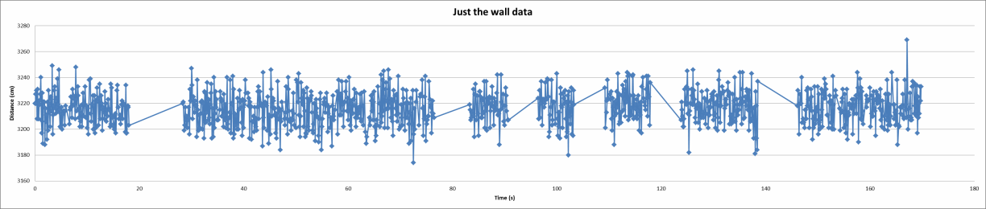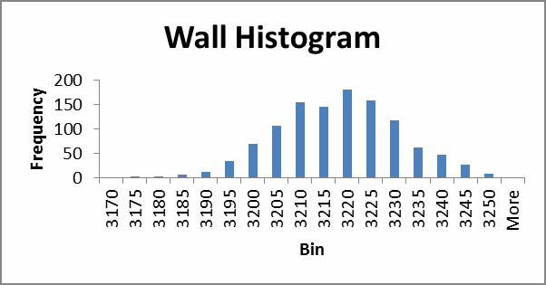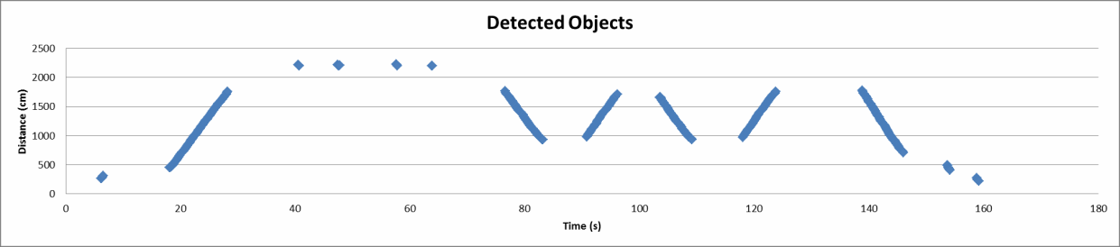

c. Removed all suspiciously minimum

and out of range measurements, as well

as any measurements of the 13

unknown objects.

|  |  |
| --- | --- |
| Median | 3217 |
| Mean | 3216.194 |
| Mode | 3221 |
| Standard Deviation | 12.62869 |

d.

* 1. 13 objects.
  2. Maximum speed is -330 cm/s
  3. 437 data points detect object. Probability = 437/(1699-137) = 0.2798